INDEX
Sno | Experiments | Signature
1 | Write a regular expression including modifiers, operators and metacharacters
2 | Write a program to show the usage of nested if statement..
3 | Write a program to create a menu driven program and show the usage of switch-case
4 | Write a program to show the usage of for/while/do while loop
5 | Write a program to implement arrays and to perform all four types of sorting
6 | Write a program to implement Array-pad(), array_slice(), array_splice(), list() functions. (use foreach wherever applicable)
7 | Write a program to show the application of user defined functions.
8 | Write a program to validate the form data using Filter_var() function.CODE
9 | Write a program to implement oops concepts.
10 | Do Form handling In PHP Design a personal Information Applicable from Batch Admitted in Academic Session 2024-25 onwards form , then Submit & Retrieve the Form Data Using $_GET(), $_POST() and $_REQUEST() Variables.
11 | Write a program to create a file
12 | Write a program to read and display the content of previously created file
13 | Create a web page and which provides File uploading and downloading a file
14 | Design a from which upload And Display Image in PHP
15 | Write a program to create a table and insert few records into it using form

PRACTICAL – 1
Write a regular expression including modifiers, operators and metacharacters.
CODE
<?php
$tests = [
'email' => 'Abc.Example+1@gmail.com',
'phone' => '+1 (415) 555-2671',
'url' => 'https://www.example-site.com/path/page?x=1#frag'
];

$emailRe = '/^(?=.{6,254}$)(?=.{1,64}@)[A-Z0-9._%+-]+@(?:[A-Z0-9-]+\.)+[A-Z]{2,}$/i';

$phoneRe = '/^(?:\+1[ -]?)?(?:\([2-9]\d{2}\)|[2-9]\d{2})[ -]?\d{3}[ -]?\d{4}$/';

$urlRe = '/\b(https?:\/\/)(?:www\.)?([A-Za-z0-9.-]+)(\/[^\s?#]*)?(?:\?[^#\s]*)?(?:#\S*)?\b/i';

echo "Email test: ";
echo preg_match($emailRe, $tests['email']) ? "Valid\n" : "Invalid\n";

echo "Phone test: ";
echo preg_match($phoneRe, $tests['phone']) ? "Valid\n" : "Invalid\n";

echo "URL test: ";
if (preg_match($urlRe, $tests['url'], $m)) {
echo "Match! Domain = " . $m[2] . "\n";
} else {
echo "No match\n";
}
?>

OUTPUT



PRACTICAL – 2
Write a program to show the usage of nested if statement..
CODE
<?php
$marks = 85;
if ($marks >= 40) {
echo "Pass<br>";
if ($marks >= 75) {
echo "Grade: Distinction";
} elseif ($marks >= 60) {
echo "Grade: First Division";
} else {
echo "Grade: Second Division";
}
} else {
echo "Fail";
}
?>
OUTPUT



PRACTICAL – 3
Write a program to create a menu driven program and show the usage of switch-case
CODE
<!DOCTYPE html>
<html>
<head>
<title>Menu Driven Program using Switch Case</title>
</head>
<body>
<h2>Menu Driven Program using Switch-Case in PHP</h2>

<form method="post" action="">
Enter First Number: <input type="number" name="num1" required><br><br>
Enter Second Number: <input type="number" name="num2" required><br><br>

<label>Select an Operation:</label><br>
<select name="choice">
<option value="1">Addition</option>
<option value="2">Subtraction</option>
<option value="3">Multiplication</option>
<option value="4">Division</option>
</select><br><br>

<input type="submit" name="submit" value="Calculate">
</form>

<?php
if (isset($_POST['submit'])) {
$num1 = $_POST['num1'];
$num2 = $_POST['num2'];
$choice = $_POST['choice'];

echo "<h3>Result:</h3>";

switch ($choice) {
case 1:
echo "Addition = " . ($num1 + $num2);
break;
case 2:
echo "Subtraction = " . ($num1 - $num2);
break;
case 3:
echo "Multiplication = " . ($num1 * $num2);
break;
case 4:
if ($num2 != 0)
echo "Division = " . ($num1 / $num2);
else
echo "Cannot divide by zero!";
break;
default:
echo "Invalid choice!";
break;
}
}
?>
</body>
</html>

OUTPUT

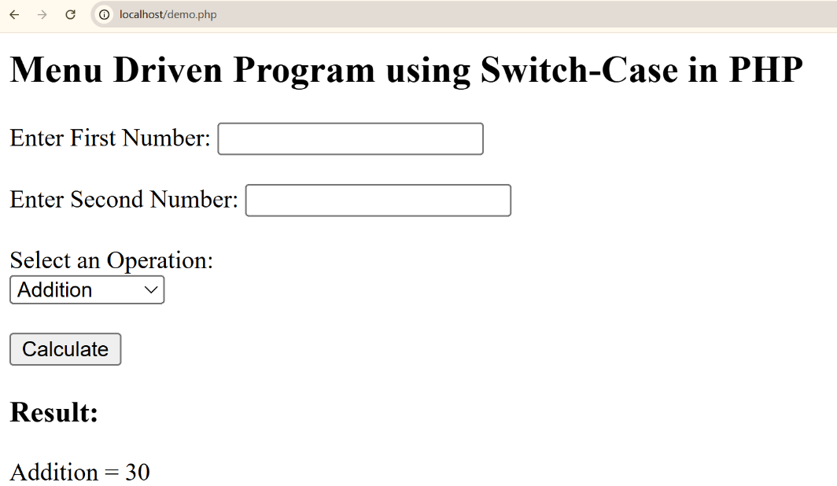

PRACTICAL – 4
Write a program to show the usage of for/while/do while loop
CODE
<?php
echo "For Loop:<br>";
for ($i = 1; $i<= 5; $i++) {
echo "$i ";
}
echo "<br>While Loop:<br>";
$j = 1;
while ($j <= 5) {
echo "$j ";
$j++;
}
echo "<br>Do While Loop:<br>";
$k = 1;
do {
echo "$k ";
$k++;
} while ($k <= 5);
?>
OUTPUT
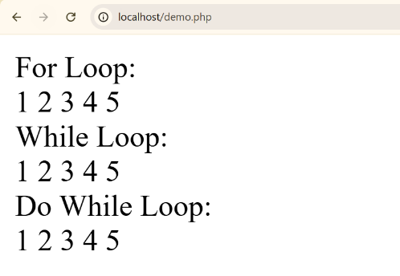

PRACTICAL – 5
Write a program to implement arrays and to perform all four types of sorting
CODE
<?php
$numbers = array(5, 3, 8, 1, 4);
echo "Original Array: ";
print_r($numbers);

// Sort in ascending order
sort($numbers);
echo "<br>Ascending Order: ";
print_r($numbers);

// Sort in descending order
rsort($numbers);
echo "<br>Descending Order: ";
print_r($numbers);

// Associative Array Sorting by Value (asort)
$assoc = array("a" => 40, "b" => 10, "c" => 30);
asort($assoc);
echo "<br>Associative Ascending by Value: ";
print_r($assoc);

// Associative Array Sorting by Key (ksort)
ksort($assoc);
echo "<br>Associative Ascending by Key: ";
print_r($assoc);
?>

OUTPUT
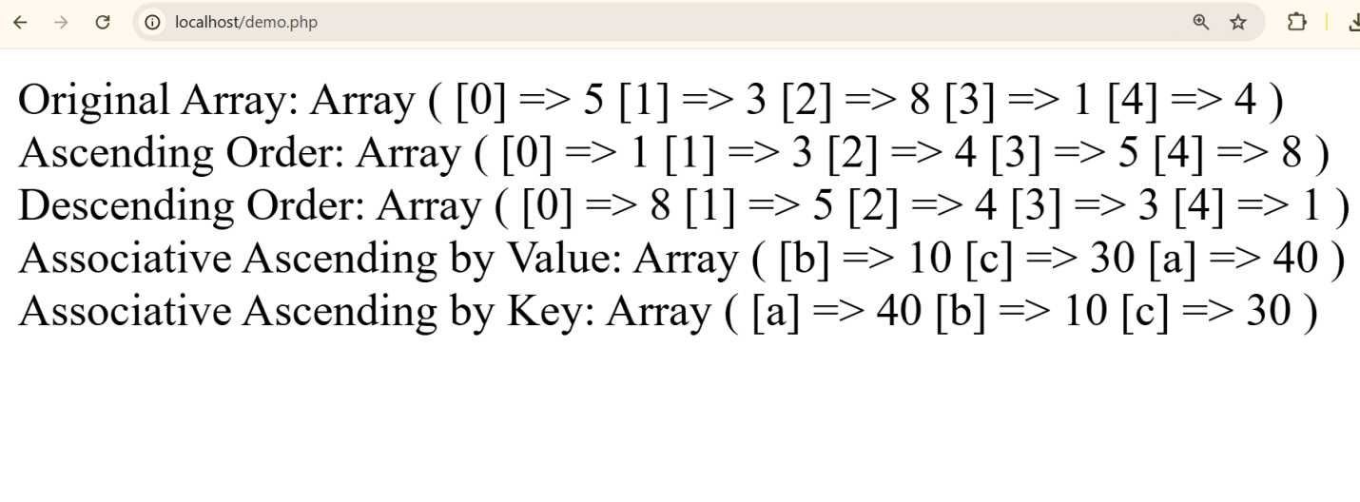

PRACTICAL – 6
Write a program to implement Array-pad(), array_slice(), array_splice(), list() functions. (use foreach wherever applicable)
CODE
<!DOCTYPE html>
<html>
<head>
<title>Array Functions in PHP</title>
</head>
<body>
<h2>Implementation of array_pad(), array_slice(), array_splice(), list() functions</h2>

<?php
$fruits = array("Apple", "Banana", "Cherry");
echo "<h3>Original Array:</h3>";
foreach ($fruits as $fruit) {
echo $fruit . "<br>";
}

$padded = array_pad($fruits, 6, "Mango");
echo "<h3>After array_pad():</h3>";
foreach ($padded as $item) {
echo $item . "<br>";
}

$sliced = array_slice($padded, 1, 3);
echo "<h3>After array_slice():</h3>";
foreach ($sliced as $item) {
echo $item . "<br>";
}

$numbers = array(1, 2, 3, 4, 5);
echo "<h3>Original Numbers Array:</h3>";
foreach ($numbers as $num) {
echo $num . " ";
}
array_splice($numbers, 1, 2, array(99, 100));

echo "<h3><br>After array_splice():</h3>";
foreach ($numbers as $num) {
echo $num . " ";
}
$student = array("ABC", "BCA", 2025);
list($name, $course, $year) = $student;
echo "<h3><br>Using list() Function:</h3>";
echo "Name: $name <br>";
echo "Course: $course <br>";
echo "Year: $year <br>";
?>
</body>
</html>

OUTPUT
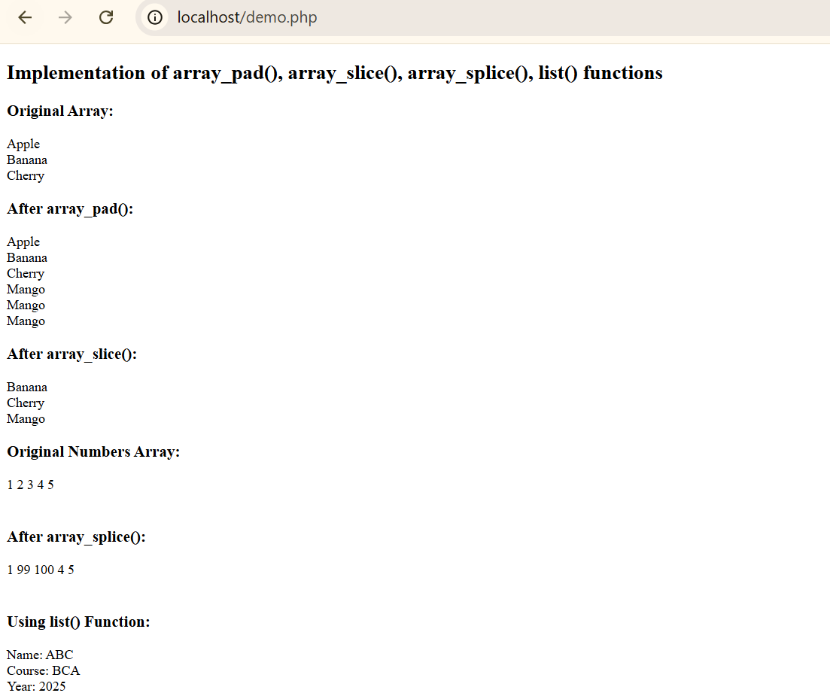

PRACTICAL – 7
Write a program to show the application of user defined functions.
CODE
<?php
function addNumbers($a, $b) {
$sum = $a + $b;
return $sum;
}
$num1 = 10;
$num2 = 20;
echo "Sum of $num1 and $num2 is: " .addNumbers($num1, $num2);
?>
OUTPUT

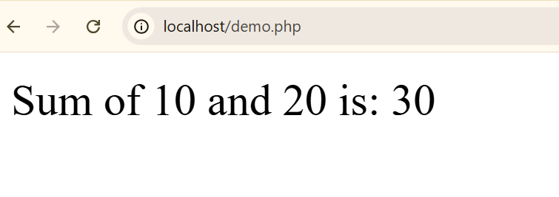

PRACTICAL – 8
Write a program to validate the form data using Filter_var() function.CODE
<!DOCTYPE html>
<html>
<head>
<title>Form Validation using filter_var()</title>
</head>
<body>
<h2>Validate Form Data using filter_var() Function</h2>

<form method="post" action="">
Name: <input type="text" name="name" required><br><br>
Email: <input type="text" name="email" required><br><br>
Age: <input type="text" name="age" required><br><br>
Website: <input type="text" name="website" required><br><br>

<input type="submit" name="submit" value="Validate">
</form>

<?php
if (isset($_POST['submit'])) {

$name = $_POST['name'];
$email = $_POST['email'];
$age = $_POST['age'];
$website = $_POST['website'];

echo "<h3>Validation Results:</h3>";

// Validate Name (only letters and spaces)
if (!preg_match("/^[a-zA-Z ]*$/", $name)) {
echo "❌ Invalid Name: Only letters and spaces allowed.<br>";
} else {
echo "✅ Name: $name<br>";
}

// Validate Email
if (!filter_var($email, FILTER_VALIDATE_EMAIL)) {
echo "❌ Invalid Email Address.<br>";
} else {
echo "✅ Email: $email<br>";
}

// Validate Age (integer)
if (!filter_var($age, FILTER_VALIDATE_INT)) {
echo "❌ Invalid Age: Must be an integer.<br>";
} else {
echo "✅ Age: $age<br>";
}

// Validate Website URL
if (!filter_var($website, FILTER_VALIDATE_URL)) {
echo "❌ Invalid Website URL.<br>";
} else {
echo "✅ Website: $website<br>";
}
}
?>
</body>
</html>

OUTPUT
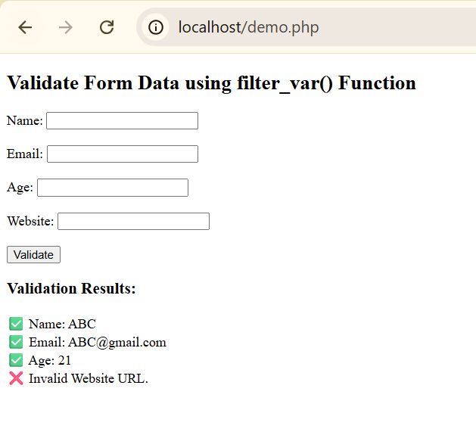

PRACTICAL – 9
Write a program to implement oops concepts.
CODE
<?php
class Person {
private $name;
private $age
// Constructor
public function __construct($name, $age) {
$this->name = $name;
$this->age = $age;
}
// Getter and Setter Methods
public function getName() {
return $this->name;
}
public function setName($name) {
$this->name = $name;
}
public function showDetails() {
echo "Name: " . $this->name . "<br>Age: " . $this->age . "<br>";
}
}
class Student extends Person {
private $course;

public function __construct($name, $age, $course) {
parent::__construct($name, $age);
$this->course = $course;

public function showDetails() {
parent::showDetails();
echo "Course: " . $this->course . "<br>";
}
}
$person1 = new Person("A", 45);
echo "<b>Person Details:</b><br>";
$person1->showDetails();
echo "<br><b>Student Details:</b><br>";
$student1 = new Student("B", 20, "BCA");
$student1->showDetails();
?>
OUTPUT

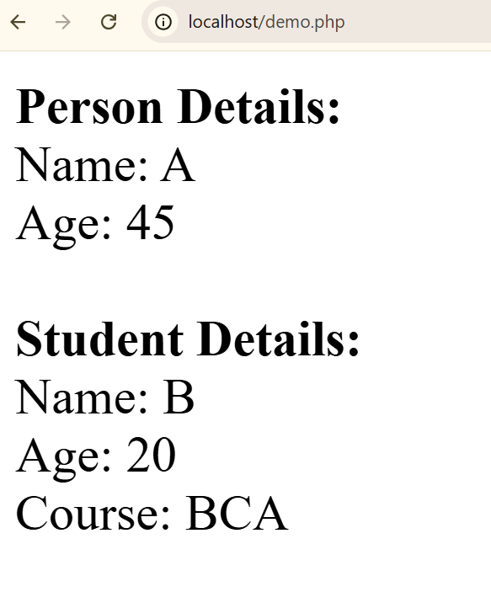

PRACTICAL – 10
Do Form handling In PHP Design a personal Information Applicable from Batch Admitted in Academic Session 2024-25 onwards form , then Submit & Retrieve the Form Data Using $_GET(), $_POST() and $_REQUEST() Variables.
CODE
File 1 — form.html
<!DOCTYPE html>
<html>
<head>
<title>Personal Information Form</title>
</head>
<body>
<h2>Personal Information Form</h2>
<form action="display.php" method="post">
<label>Name:</label>
<input type="text" name="name" required><br><br>
<label>Email:</label>
<input type="email" name="email" required><br><br>
<label>Age:</label>
<input type="number" name="age" required><br><br>
<label>Gender:</label>
<input type="radio" name="gender" value="Male"> Male
<input type="radio" name="gender" value="Female"> Female<br><br>
<input type="submit" value="Submit">
</form>
</body>
</html>

OUTPUT
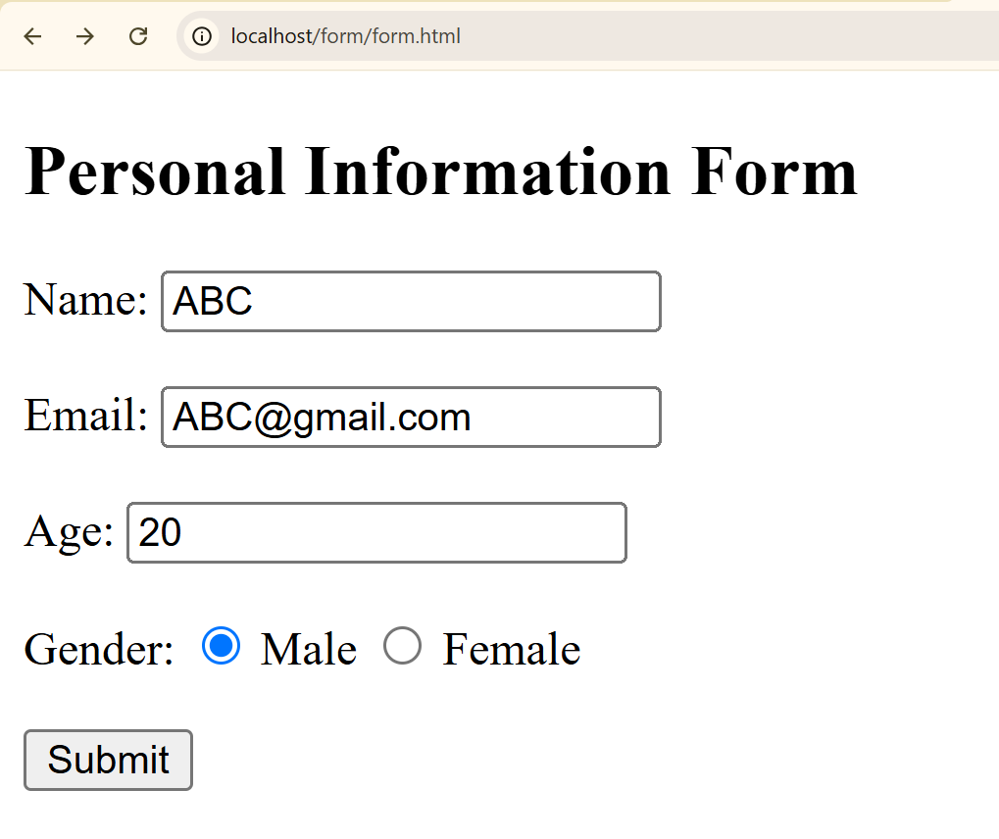
CODE
File 2 — form.html
<?php
if ($_SERVER["REQUEST_METHOD"] == "POST") {
$name = $_POST['name'];
$email = $_POST['email'];
$age = $_POST['age'];
$gender = $_POST['gender'];
echo "<h2>Data Received Using \$_POST</h2>";
echo "Name: $name<br>";
echo "Email: $email<br>";
echo "Age: $age<br>";
echo "Gender: $gender<br><hr>";
}

// Using $_GET (Try by changing method="get" in form)
if ($_SERVER["REQUEST_METHOD"] == "GET" && !empty($_GET)) {
echo "<h2>Data Received Using \$_GET</h2>";
print_r($_GET);
echo "<hr>";
}
if (!empty($_REQUEST)) {
echo "<h2>Data Received Using \$_REQUEST</h2>";
print_r($_REQUEST);
}
?>
OUTPUT
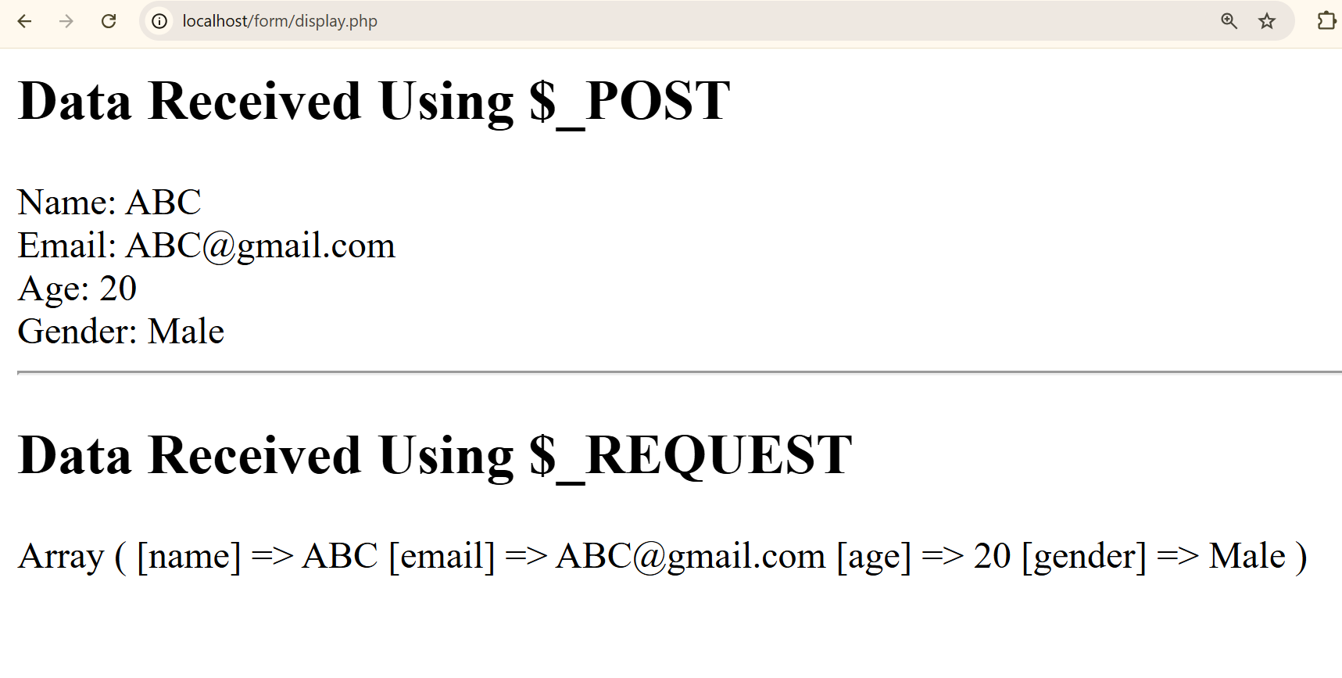

PRACTICAL – 11
Write a program to create a file
CODE
<?php
$filename = "sample.txt";
$file = fopen($filename, "w"); // "w" = write mode (creates new file if not exists)
if ($file) {
echo "File '$filename' created successfully!<br>";
fwrite($file, "Hello, this is a file created using PHP.\n");
fwrite($file, "File Handling Demonstration.\n");

fclose($file);
echo "Data written successfully and file closed.";
} else {
echo "Error: Unable to create file!";
}
?>
OUTPUT
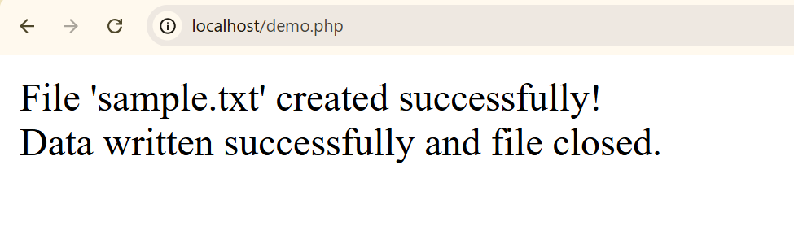

PRACTICAL – 12
Write a program to read and display the content of previously created file.
CODE
<?php
$filename = "sample.txt"; // Name of the file created earlier
if (file_exists($filename)) {
$file = fopen($filename, "r");
echo "<h3>Contents of '$filename':</h3>";
while (!feof($file)) {
$line = fgets($file);
echo $line . "<br>";
}
fclose($file);
} else {
echo "Error: File '$filename' not found!";
}
?>
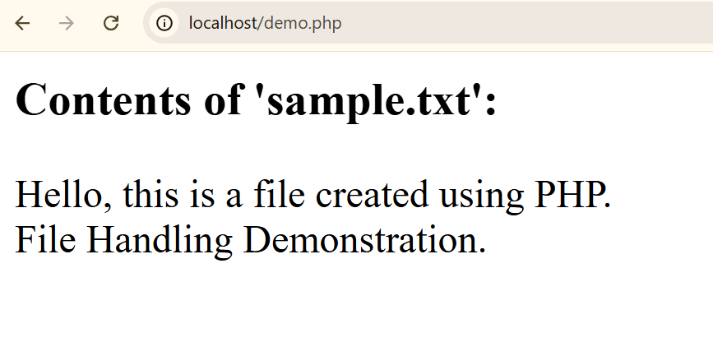

PRACTICAL – 13
Create a web page and which provides File uploading and downloading a file
CODE
Upload.html
<!DOCTYPE html>
<html>
<head>
<title>File Upload and Download</title>
</head>
<body>
<h2>Upload a File</h2>
<!--enctype="multipart/form-data" is required for file uploads -->
<form action="upload.php" method="post" enctype="multipart/form-data">
<label>Select File:</label>
<input type="file" name="uploadedFile" required><br><br>
<input type="submit" name="upload" value="Upload File">
</form>
</body>
</html>
OUTPUT
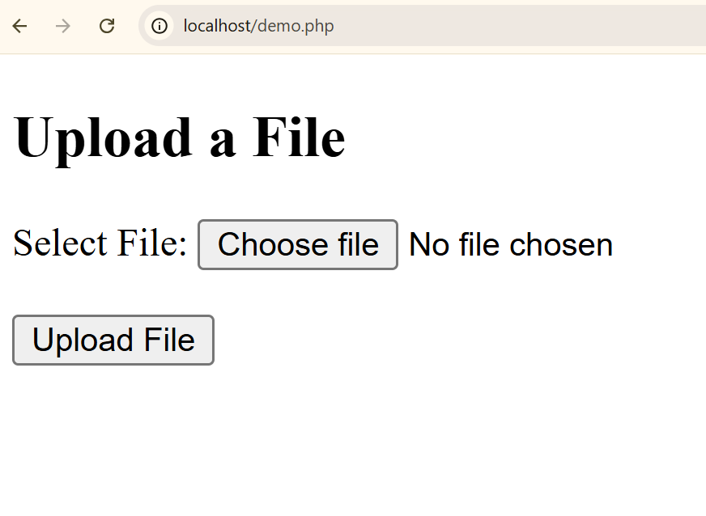

Upload.php
<?php
$target_dir = "uploads/"; // Folder to store uploaded files
$target_file = $target_dir .basename($_FILES["uploadedFile"]["name"]);
if (isset($_POST["upload"])) {
if (move_uploaded_file($_FILES["uploadedFile"]["tmp_name"], $target_file)) {
echo "<h3>File Uploaded Successfully!</h3>";
echo "File Name: " .basename($_FILES["uploadedFile"]["name"]) . "<br>";
echo "<a href='download.php?file=" .urlencode(basename($_FILES["uploadedFile"]["name"])) . "'>Click here to Download File</a>";
} else {
echo "Error: File not uploaded!";
}
}
?>
download.php
<?php
if (isset($_GET['file'])) {
$filename = basename($_GET['file']);
$filepath = 'uploads/' . $filename;

if (file_exists($filepath)) {
header('Content-Description: File Transfer');
header('Content-Type: application/octet-stream');
header('Content-Disposition: attachment; filename="' . $filename . '"');
header('Content-Length: ' .filesize($filepath));

// Read file and send to browser
readfile($filepath);
exit;
} else {
echo "Error: File not found!";
}
}
?>
OUTPUT
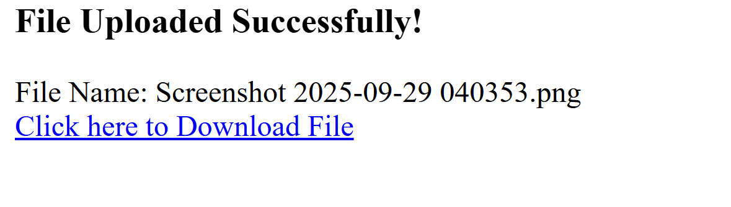

PRACTICAL – 14
Design a from which upload And Display Image in PHP
CODE
<!DOCTYPE html>
<html>
<head>
<title>Upload and Display Image in PHP</title>
</head>
<body>
<h2>Image Upload and Display Example</h2>

<form action="" method="post" enctype="multipart/form-data">
<label>Select an Image to Upload:</label><br><br>
<input type="file" name="image" required><br><br>
<input type="submit" name="submit" value="Upload">
</form>

<?php
if (isset($_POST['submit'])) {

$target_dir = "uploads/";

if (!is_dir($target_dir)) {
mkdir($target_dir, 0777, true);
}

$target_file = $target_dir .basename($_FILES["image"]["name"]);

$imageFileType = strtolower(pathinfo($target_file, PATHINFO_EXTENSION));

$allowed_types = array("jpg", "jpeg", "png", "gif");

if (in_array($imageFileType, $allowed_types)) {
if (move_uploaded_file($_FILES["image"]["tmp_name"], $target_file)) {
echo "<h3>✅ Image Uploaded Successfully!</h3>";
echo "<imgsrc='$target_file' alt='Uploaded Image' width='300' height='300'>";
} else {
echo "<h3>❌ Sorry, there was an error uploading your file.</h3>";
}
} else {
echo "<h3>❌ Only JPG, JPEG, PNG, and GIF files are allowed.</h3>";
}
}
?>
</body>
</html>

OUTPUT
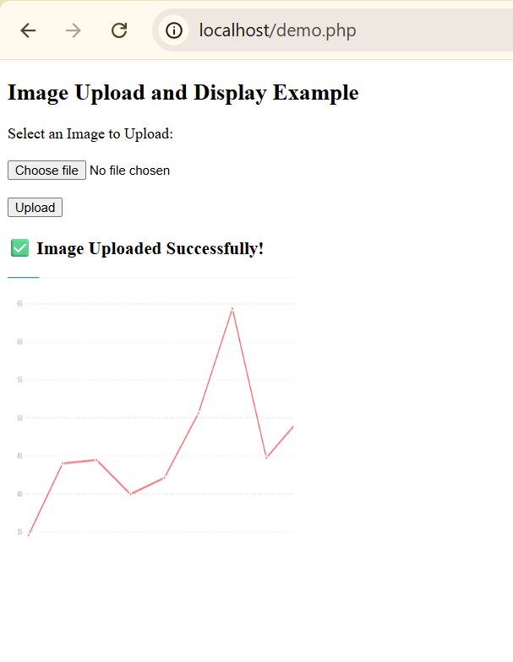

PRACTICAL – 15
Write a program to create a table and insert few records into it using form
CODE
create_table.php
<?php

$servername = "localhost";
$username = "root";
$password = "";
$dbname = "college";

$conn = new mysqli($servername, $username, $password, $dbname);

if ($conn->connect_error) {
die("Connection failed: " . $conn->connect_error);
}

$sql = "CREATE TABLE students (
id INT(6) AUTO_INCREMENT PRIMARY KEY,
name VARCHAR(50) NOT NULL,
email VARCHAR(50),
course VARCHAR(50)
)";

if ($conn->query($sql) === TRUE) {
echo "Table 'students' created successfully!";
} else {
echo "Error creating table: " . $conn->error;
}

$conn->close();
?>

insert_form.html
<!DOCTYPE html>
<html>
<head>
<title>Insert Student Record</title>
</head>
<body>
<h2>Student Information Form</h2>
<form action="insert_data.php" method="post">
<label>Name:</label>
<input type="text" name="name" required><br><br>

<label>Email:</label>
<input type="email" name="email" required><br><br>

<label>Course:</label>
<input type="text" name="course" required><br><br>

<input type="submit" name="submit" value="Insert Record">
</form>
</body>
</html>
# Program to perform Linear Search
insert_data.php
<?php

$servername = "localhost";
$username = "root";
$password = "";
$dbname = "college";

$conn = new mysqli($servername, $username, $password, $dbname);

if ($conn->connect_error) {
die("Connection failed: " . $conn->connect_error);
}

if (isset($_POST['submit'])) {
$name = $_POST['name'];
$email = $_POST['email'];
$course = $_POST['course'];

$sql = "INSERT INTO students (name, email, course) VALUES ('$name', '$email',
'$course')";

if ($conn->query($sql) === TRUE) {
echo "<h3>Record inserted successfully!</h3>";
} else {
echo "Error: " . $sql . "<br>" . $conn->error;
}
}

$conn->close();
?>

OUTPUT
